SINGLET: WOOL 4-PLY Premmie 24 January 2021
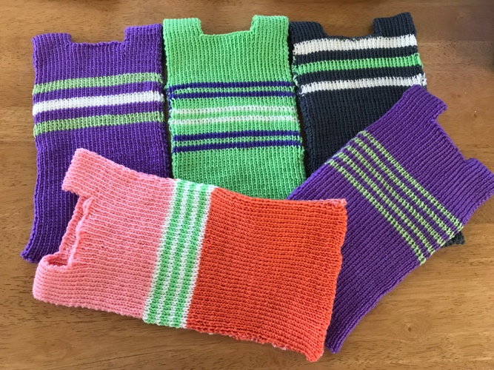
Hand-knit Instructions from Jean Miles, CWA.
Cast on 64 stitches. Knit 9 inches in 2:2 rib. Cast off 26 stitches in middle of row for neck. Knit 1 ½ inches to go over shoulders. Cast on 26 in the middle of the row and knit 9 inches. Cast off.
Colours, stripes etc. OK.
Passap instructions:
1 Cast on 64 sts for 1:1 rib, Zigzag T 1 ½, 2 rows circular CX T 2 ¾. (=RC 3)
2 Rib 1:1, T 4 ¾ to RC 86. (Back of singlet completed.)
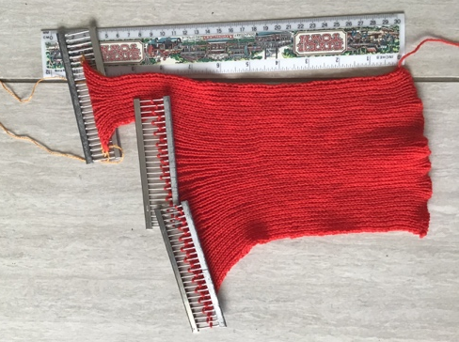
Cast off centre 26 sts and work shoulder straps on 19 sts each end, thus:
3 Transfer all stitches to front bed. Put out of work all but 19 stitches at right. Or Put on waste yarn/dekker combs (Passap).
4 Rearrange these 19 stitches for 1:1 rib. Work 17 rows. Break yarn. Transfer to front. As in (3), take off.
5 Replace centre 26 stitches from holder, unravel and cast off, holding last st to knit with shoulder.
6 Return rem 19 from holder and unravel. Transfer for 1:1 rib, 17 rows of second shoulder. Leave stitches in place. Yarn is at left.
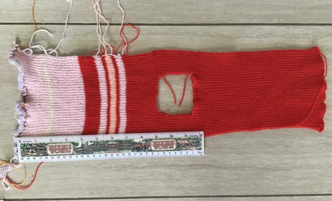
7 For FRONT, return 19 stitches from waste yarn or holder to RHS. Transfer for 1:1. Bring up central 26 needles for 1:1. Work one row, then twist each of the 26/ E-wrap. Continue in 1:1 rib to RC 83.
8 Transfer to front, then Cast off, or onto waste yarn to cast off by hand. Finish off ends, and stitch side seams.

